**Merchandise Sales Analysis - Entertainment Sector**

Pooja Joshi & E.Code [E25007]

# Overview :

# The purpose of this task is to analyze the merchandise sales for different movie franchises by integrating social media engagement data and identifying patterns or relationships between movie popularity, attendance, and merchandise sales.

# Objective:

· To merge movie data with merchandise sales and social media engagement data.

· To analyze the combined data for insights into franchise performance.

· To visualize the key metrics such as merchandise sales by franchise.

# Assigned Task(s) :

· Merge the movie data with merchandise and social media engagement data.

· Calculate a social media engagement score based on interaction metrics.

· Group the data by franchise and analyze average merchandise sales and attendance.

· Visualize merchandise sales data to identify top-performing franchises.

# Task Details :

· **Task 1**: Data Merging

* **Status**: Completed
* **Details**: Data from multiple sources, including merchandise sales and social media engagement, was successfully merged into a single DataFrame. The franchise column was used as the key for merging.

**Task 2: Analysis of Relationship Between Popularity and Attendance Count**

**Status**: Completed

**Details** : The provided scatter plot analyzes the relationship between "Popularity" and "Attendance Count," which is used as a proxy for merchandise sales. This visualization is directly relevant to where a custom engagement score was calculated using a weighted sum of likes, shares, and comments.

**Popularity**: Likely represents the calculated engagement score, reflecting the weighted sum of social media interactions (likes, shares, and comments).

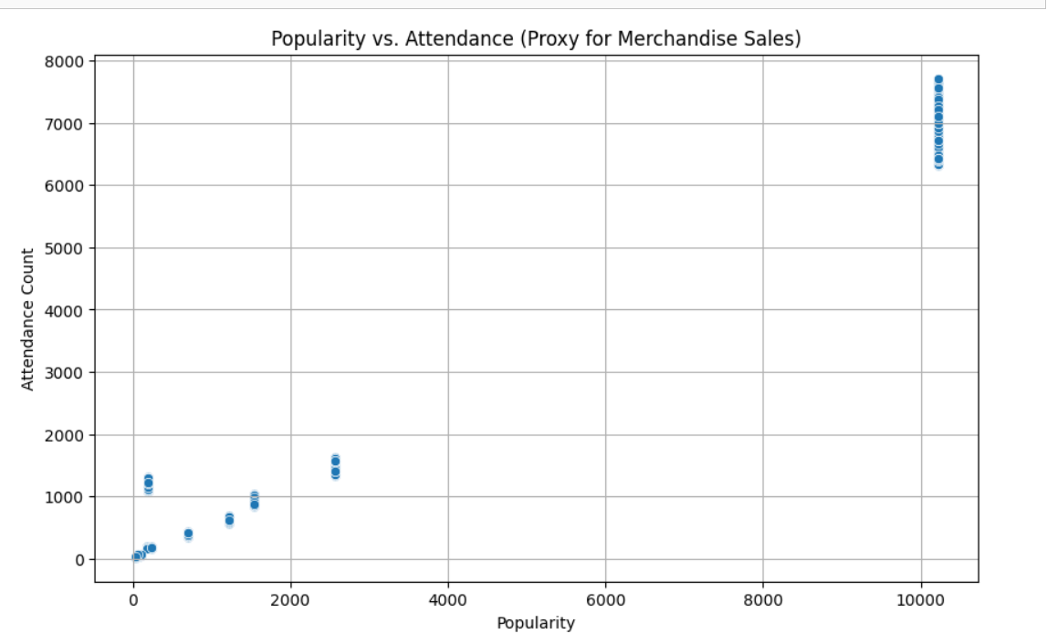

**Attendance** Count: Used as a proxy for merchandise sales, suggesting that higher attendance is correlated with higher merchandise sales.

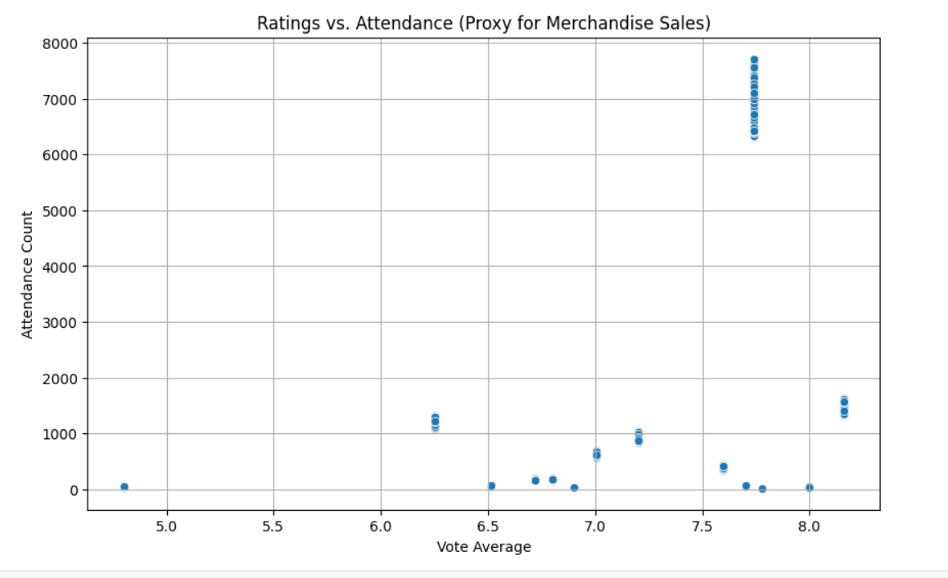

· **Task 3**: Merchandise Sales Analysis by Franchise

* **Status**: Completed
* **Details**: The data was grouped by franchise, and mean merchandise sales and attendance were computed. A bar plot was created to visualize the average merchandise sales across different franchises.

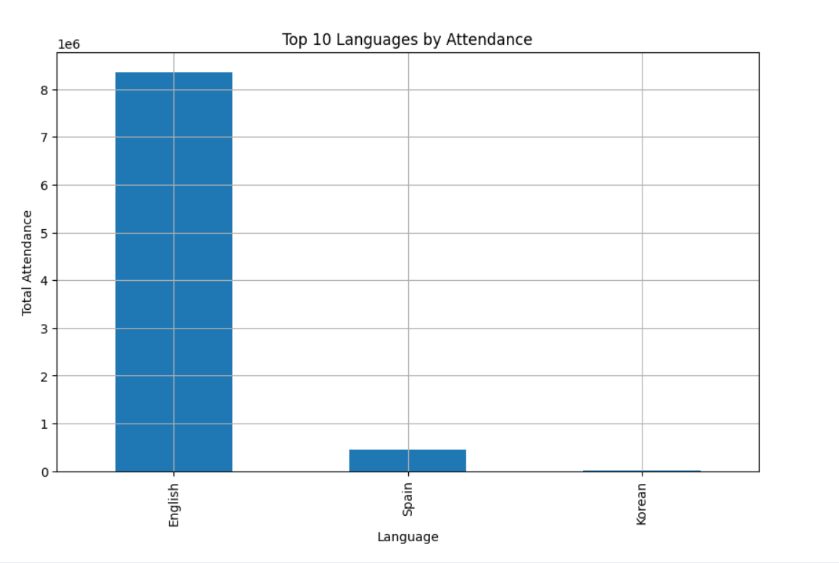

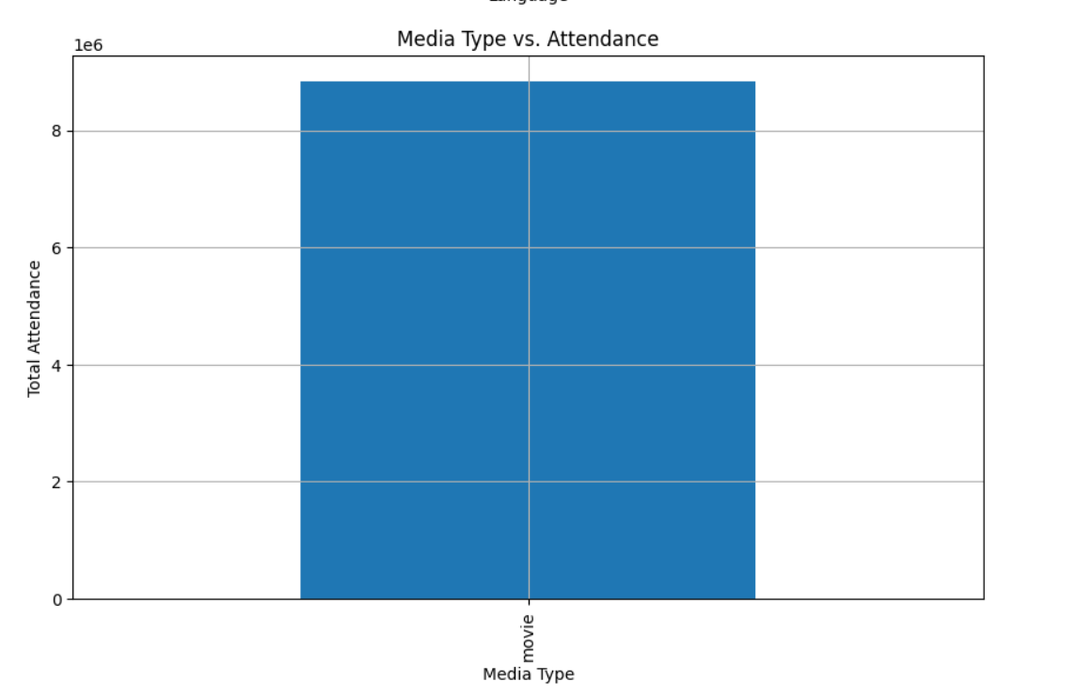

**Task 4**: Visualization of Merchandise Sales by Franchise

* **Status**: Completed
* **Details**: A bar plot was created to visualize the average merchandise sales across different franchises using Seaborn. The franchises analyzed include "Franchise A", "Franchise B", and "Non-Franchise". Franchise B showed the highest average merchandise sales, while the Non-Franchise category had the lowest.

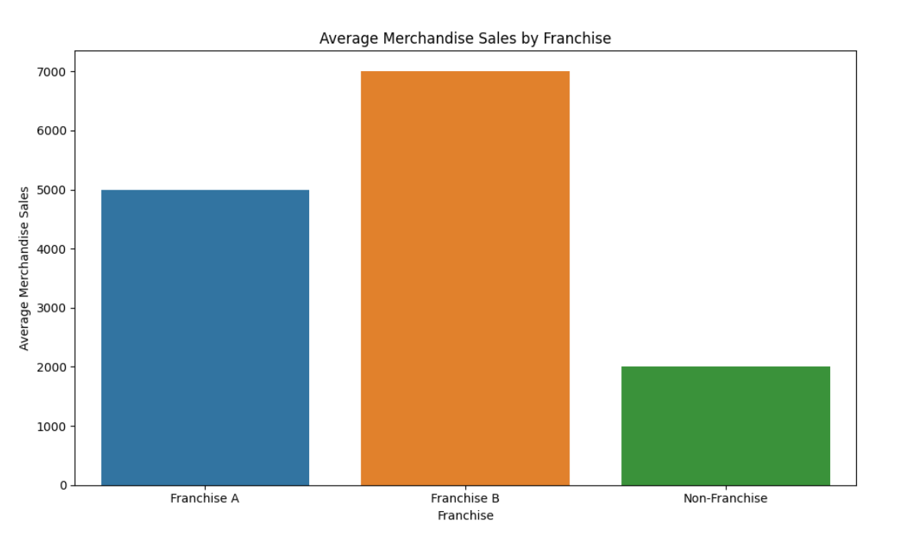

· **Task 5**: Visualization of Social Media Engagement Score

* **Status**: Completed
* **Details**: A second bar plot was generated to compare social media engagement scores across franchises. "Franchise A" displayed the highest engagement score, correlating well with merchandise sales.

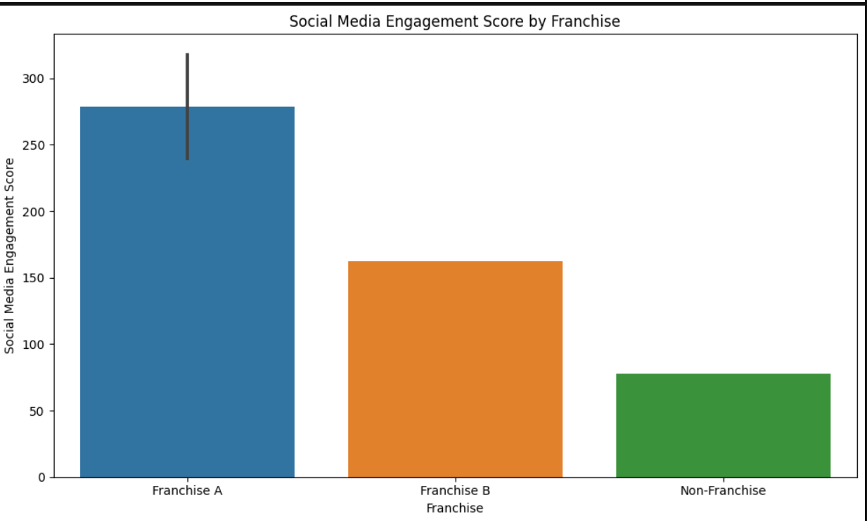

· **Task 6**: Analysis of Merchandise Sales vs Social Media Engagement Score

* **Status**: Completed
* **Details**: A scatter plot was created to analyze the relationship between social media engagement and merchandise sales. It showed a positive trend, suggesting that higher social media engagement is associated with higher merchandise sales.

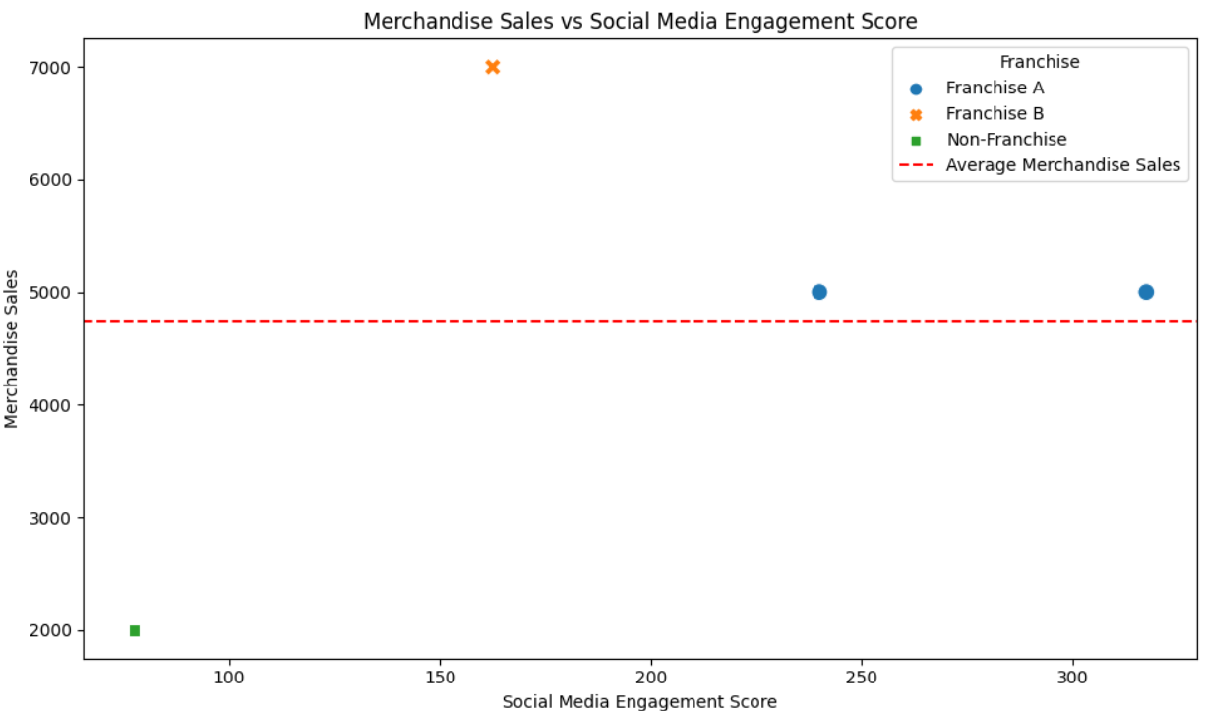

·

# Next Steps :

· **Upcoming Tasks:** Experiment with various models and perform hyperparameter tuning to enhance performance.

· **Goals:** Aim to improve model accuracy and evaluate the system using new data sources.

# Conclusion :

# **Summary**: The project has made significant strides in developing a personalized ad targeting system for the entertainment sector. By recommending ads based on predicted user segments, the system aims to increase the relevance of content displayed to users.

# **Acknowledgments**: Thank the audience for their time and attention.

# Instructions:

1. Use Google Docs. Single Column
2. TNR stands for Times New Roman: B - Bold
3. Use images as required with proper references
4. Use charts, tables as per your requirement.
5. Number of Pages: 2 to 8 for each task report.